EXPERIMENT : 12

**AIM :** To write an assembly language program to implement 8-bit addition using 8085 processor.

**ALGORITHM :**

1) To generate a 1's complement for any given binary number, you only need to invert that number.

2) To generate a 2's complement for any given binary number, you need to invert it.

3) Then you need to add 1 to the LSB (Least Significant Bit) of the generated result.

PROGRAM:

LDA 3000

CMA

STA 3001

ADI 01

STA 3002

HLT

INPUT :

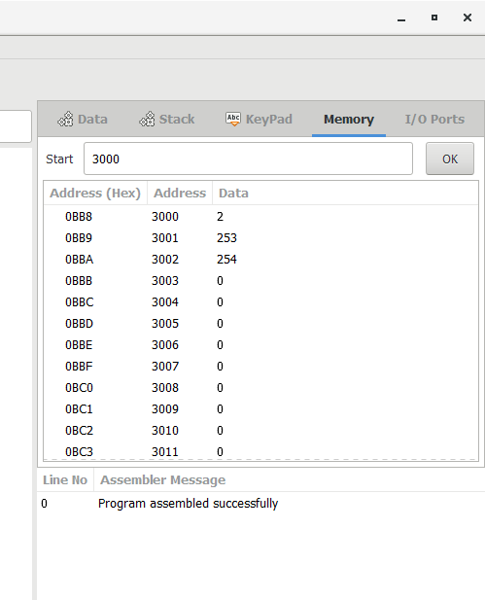

**OUTPUT :**

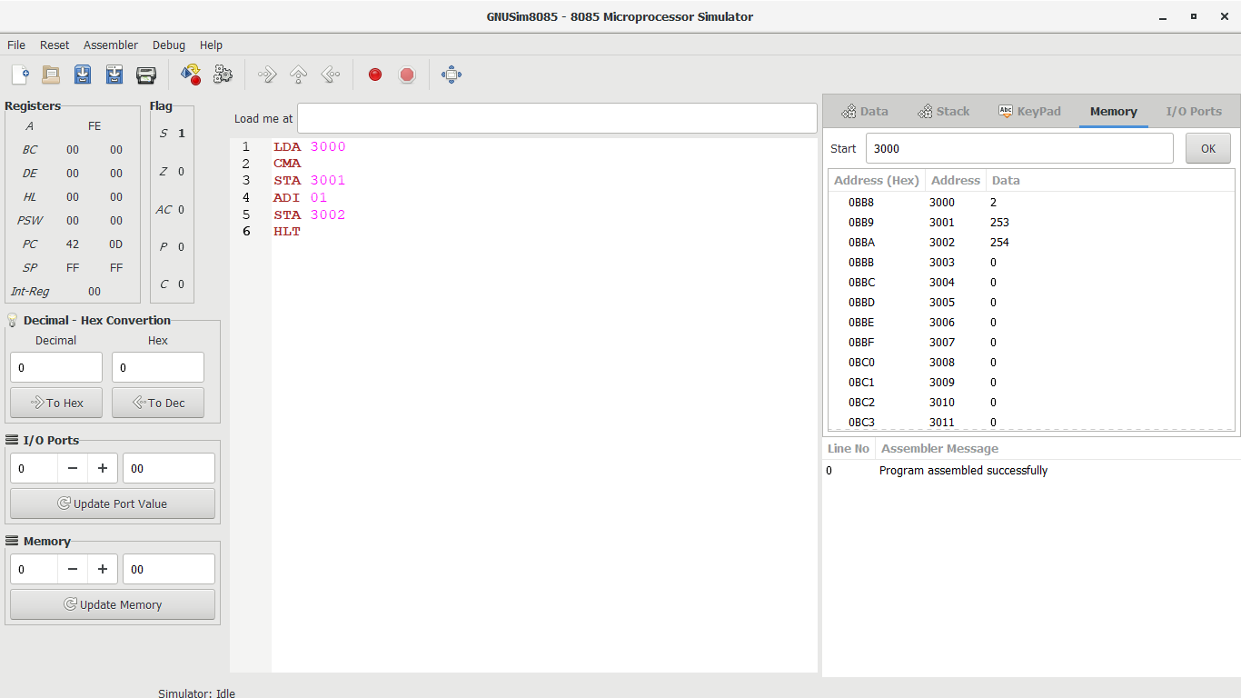

**RESULT :**

**Thus the program was executed successfully using 8085 processor simulator**